# Lab02 Exercise

# Muhammad Naimat Ullah Khan

# Lab 02

# 21K – 4540

1. Write scripts /commands / syntax to take input and print your name, age and nationality.

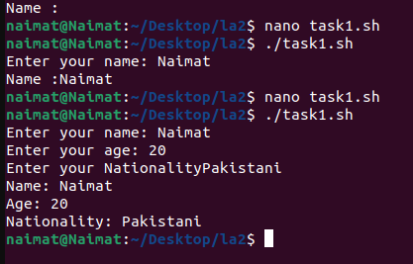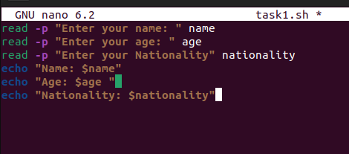

1. Write scripts /commands / syntax that take input and check the number is even or odd.

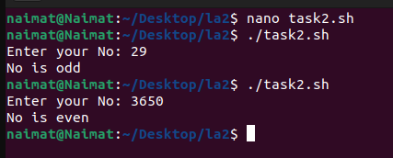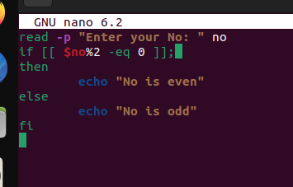

1. Write scripts /commands / syntax to find out the cube and squre of given input number.

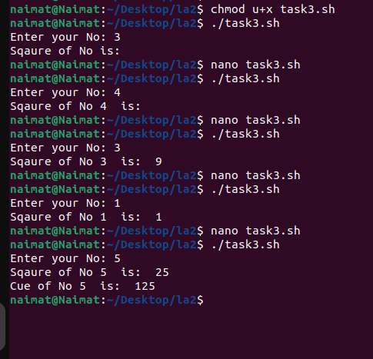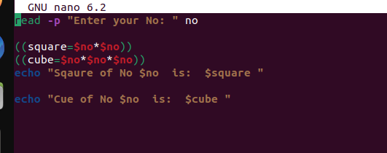

1. Write scripts /commands / syntax to print a message “Welcome to Shell Scripting ” 5 times.

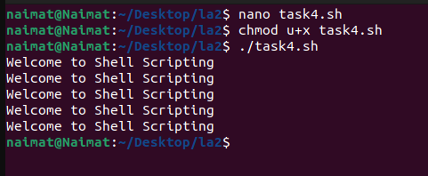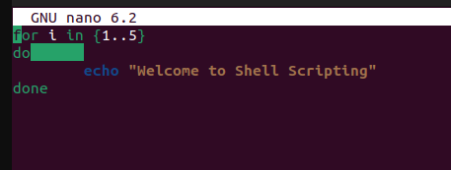

1. Write scripts /commands / syntax to generate the even numbers series up to nth term.

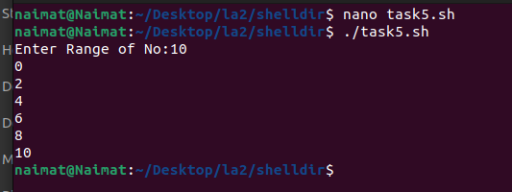

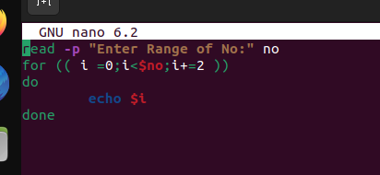

1. Write scripts /commands / syntax that take input and check the number is prime or not.

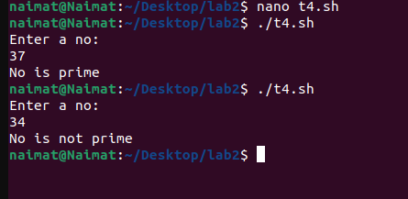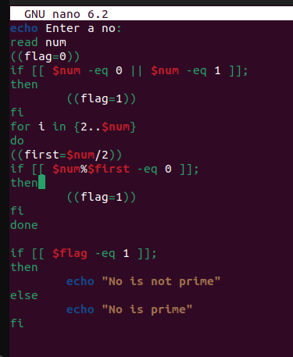

1. Write scripts /commands / syntax that take input and check the maximum and minimum of 5 input numbers.

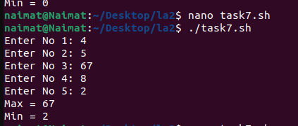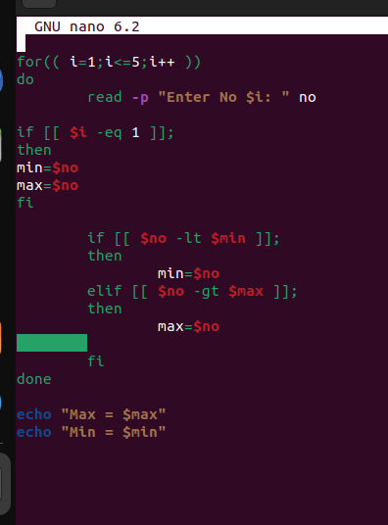

1. Write scripts /commands / syntax for moving files into three subdirectories directories:
   1. shelldir, cdir, jpgdir according to their extensions.

